Before Optimization

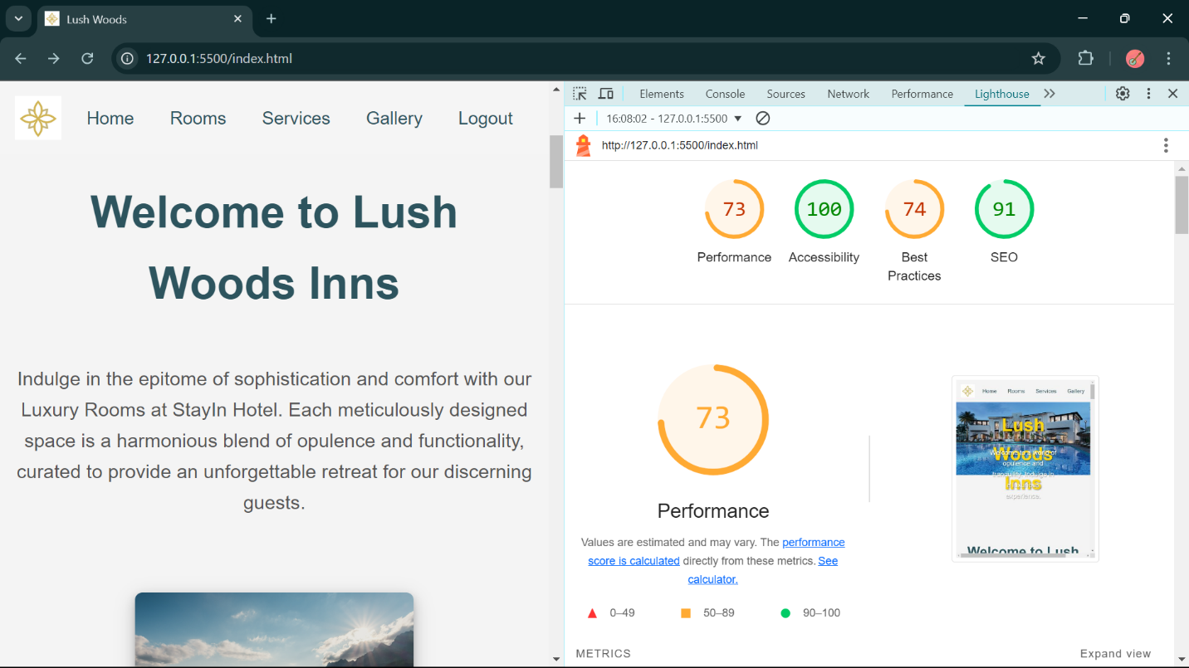

After Optimization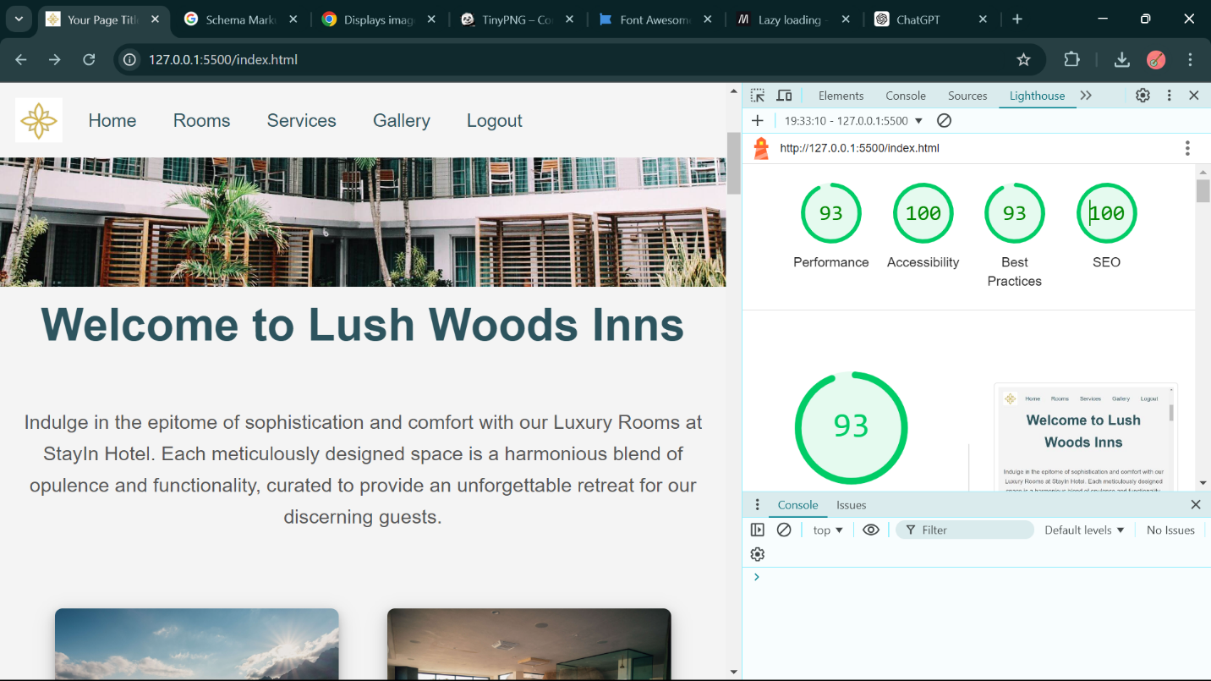

Analysis;

The website was built as a hotel landing page

It has a slide-show for header, there are few cards to show the rooms and their services.

Then there is several services showed that hotel gives.

In end, there is a gallery of photos of the hotel.

Things I did to made its performance better;

First, I reduced the .js and .css files and used inline JavaScript and CSS

Second, I minified the sizes of the images used using TinyPng

Third, I used the loading = “lazy” for my images

Fourth, I set the dimensions and object-fit for the images.

Fifth, I removed any error that were caused on runtime.

Sixth, I added meta tags to improve the SEO.